“Protest and Stagnation: The Western World, 1965-1985”
Chapter 29 Reading Guide Western Civilization - 10th Ed. - Spielvogel

Name:________________________________ Period:____________
MAJOR THEMES / BIG QUESTIONS: (as you work through the chapter, bear these questions in mind)

- What new rights did women gain in the postwar period, and how were gender roles affected within the family? How did this new freedom affect women’s participation in politics and economic life? (PP-4, SP-1, SP-12, IS-4, IS-6, IS-9)
- Why did Green parties and gay and lesbian groups form, and what effect did they have on Western European society? (OS-4, SP-9, IS-7, IS-10)
- What caused the rise of the youth movement of the 1960s, and what effect did it have on European society? (SP-9, SP-17, IS-7, IS-10)
- How did the rise of socialist parties and social welfare programs impact the lives of Western Europeans? (PP-13, PP-15)
- What effect did globalization, new technologies, and increased trade with the United States have on the lives of Europeans? (INT-6, INT-7, INT-8, INT-10, INT-11, PP-1, PP-5, SP-5)
- What were the causes of rebellion in Eastern Europe, and how did the USSR and Western Europe react to it? (SP-9, SP-17)
- In what ways did the art, literature, music, and architecture of this period differ from that of earlier periods? Why? (OS-10, OS-13)

29.1 A Culture of Protest
- What were the goals of the revolt in:

 | Goals | To what extent Goals Achieved?
sexual mores
youth protest and student revolts
Feminist movement
Antiwar protests

29.2 A Divided Western World
2. (Between 1965-1985) What were the major political developments in:

Soviet Union
Eastern Europe
Western Europe
United States

29.3 The Cold War: The Move to Detente
3. What were the main events in the Cold War Between 1965 and 1985? How important was the role of detente in those events?

29.4 Society and Culture in the Western World
4. What were the major social developments in the Western world between 1965 and 1985? What were the major cultural developments in the Western world between 1965 and 1985?

Historical Thinking
The Times They Are A-Changin”: The Music of Youthful Protest (Contextualization)
- What problems did Bob Dylan suggest that youth were protesting in the United States

1968: The Year of Student Revolts (Comparison)
6. How similar were the grievances of those students to each other? What were the main differences?

Betty Friedan: The Problem That Has No Name (Comparison)
7..How similar is Friedan’s critique to the one implied by Ibsen in A Doll’s House (pp.708-709)

Opposing ViewPoints: Czechoslovakia, 1968: Two Faces of Communism
(Patterns of Continuity and Change Over Time)

8. How was the Czech experience similar to and different from the Hungarian experience in 1956?
Similar | Different

Margaret Thatcher: Entering a Man’s World (Contextualization)
9. What conditions made it favorable for Thatcher to be selected to run for Parliament?

The Fury of the Red Guards (Comparison)
10. How did the Red Guards’ activities compare to those of the revolutionary groups you have learned about?

The Limits of Modern Technology (Historical Causation)
11. How did Schumacher explain the changes in the world’s economy and resources? How did he think people should respond to them?

12. Photo Analysis
Protests in Paris
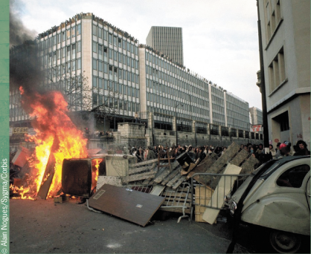
Youth Culture in the 1960’s
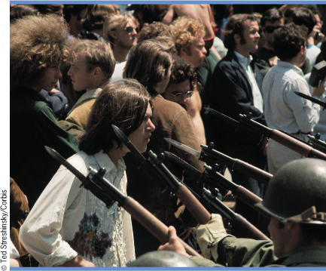
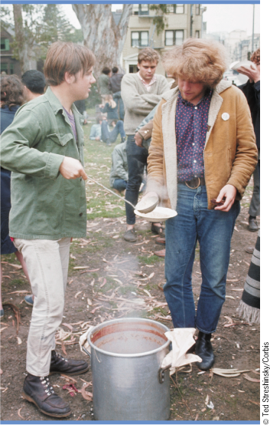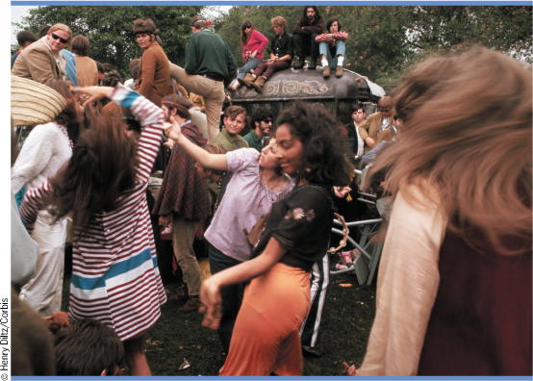
Women’s Liberation Movement
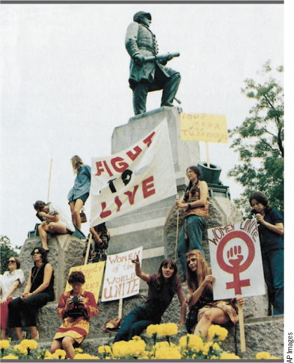
Soviet Invasion of Czechoslovakia, 1968
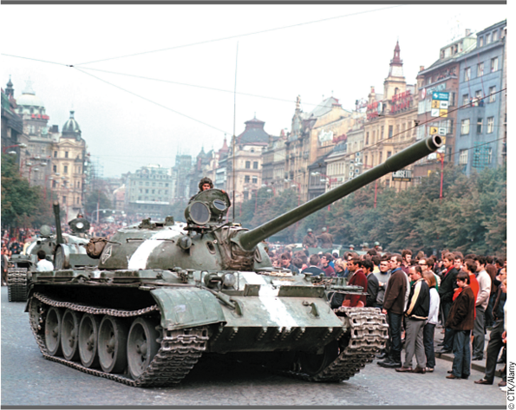
Margaret Thatcher
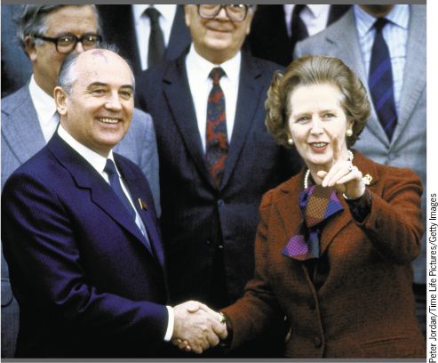
Iron Landy
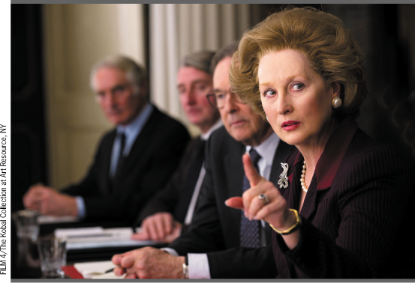
The Vietnam War
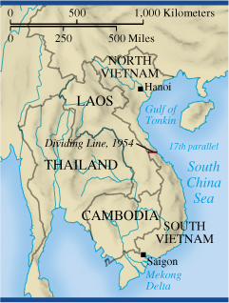
The Second Vietnam War
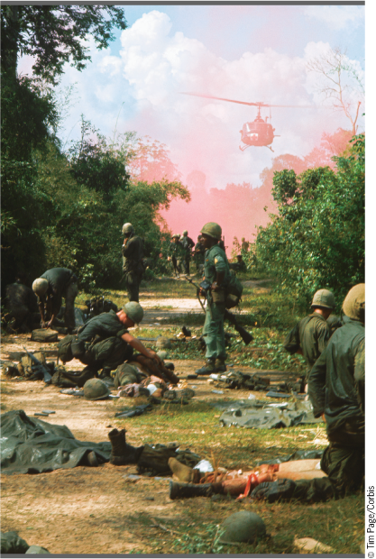
The Great Proletarian Cultural Revolution
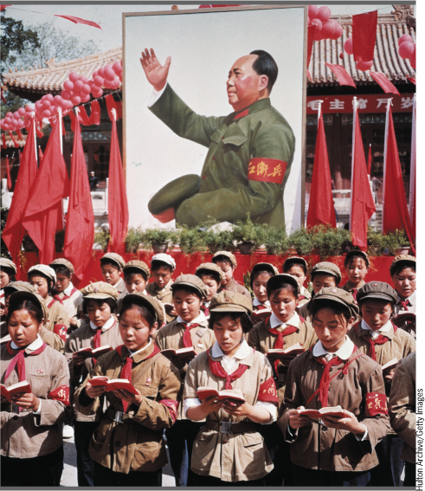
On the Moon
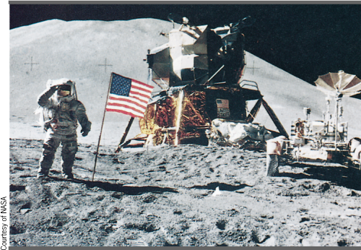
Robert Smithson, Spiral Jetty
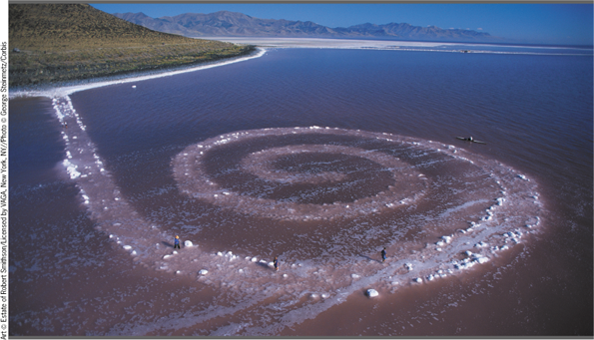
Charles Moore, Piaza d’Italia
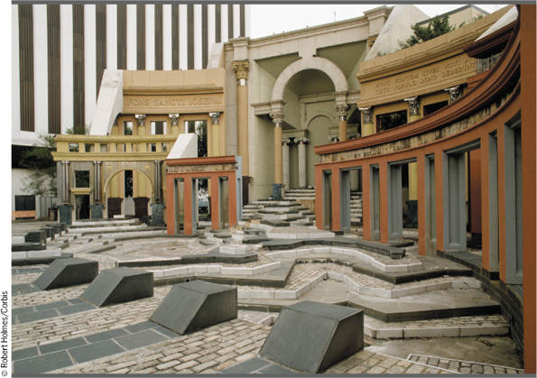

- What new rights did women gain? How were gender roles affected within the family? How did this new freedom affect women’s participation in politics and economic life?
14. Why did green parties and gay and lesbian groups form? How did green parties and gay and lesbian groups form?
15. What effect did the youth movement of the 1960s have on European Society?
16. What were the causes of Rebellion in Eastern Europe? How did the USSR react to it?

17 In what ways did the following differ from that of earlier periods? Why?
 | Differ From Earlier Period | Why
Art
Literature
Music
Architecture

Key Terms and Identifications

- University of Nanterre, 1968
- permissive society
- the birth control pill
- marijuana
- Timothy Leary and LSD
- Herbert Marcuse’s One-Dimensional Man
- feminism and Betty Fridan’s Feminine Mystique
- Anitwar protests and Kent State
- Brezhnev Doctrine
- detente
- Lech Walesa and Solidarity
- Hungary’s Janos Kadar
- The Prague Spring
- East Germany’s Walter Ulbricht and Erich Honecker
- the Berlin Wall
- Willy Brandt and Ostpolitik
- Margaret Thatcher (the “Iron Lady”) and Thatcherism
- Falklands Island and the Falklands War
- France’s Francois Mitterrand
- Italy’s Eurocommunism
- The European Community/EC
- Richard Nixon’s “southern Strategy”
- Watergate
- Jimmy Carter and stagflation
- Ayatollah Khomeini and American hostages
- the Reagan Revolution and “supply-side economics”
- Canada’s Pierre Trudeau and Brian Mulroney
- Second Vietnam War
- the Vietcong
- the domino theory
- Mao Zedong and the Great Proletarian Cultural Revolution
- the “four olds,” “permanent revolution,” and the Red Guards
- Nixon, Zedong and a j”strategic relationship”
- Antiballistic Missile Treaty, 1972
- “equivalence”
- Helsinki Agreements, 1975
- the “evil empire”
- Strategic Defense Initiative (SDI)/”Star Wars”
- the space race and Sputnik
- Grace Hooper and COBOL
- E.F. Schumacher’s Small is Beautiful
- Chernobyl, 1986
- Green parties
- Postmodernism
- Ferdinand de Saussure and structuralism
- Jacques Derrida and deconstruction
- Allen Kaprow and “happenings”
- “Magic realism” and Gabriel Garcia Marquez’s One Hundred Years of Solitude
- Milan Kundera’s The Unbearable Lightness of Being
- Olivier Messiaen and serialism
- Philip Glass’s Einstein on the Beach
- “peace and love”
- Punk rock and hip-hop
- “mass sports” and the World Cup
- Marshall McLuhan and the “global village”

Chapter Review
      - What were the major turning points in the Cold War between 1965 and 1985?
2. What were the major successes and failures of Western European democracies between 1965 and 1985, and How did Soviet policies affect the Eastern European states during the same time period?
3. What role did popular culture play in the Western world between 1965 and 1985?

Short-answer Questions
- Using your knowledge of European history, answer parts A, B, and C below.
The Cold War played out on the global stage and ultimately led to limited “hot wars” in Asia, Africa, Latin America, and the Caribbean. Choose one of the hot wars and
- Briefly explain ONE specific factor that led to the war
- Briefly explain ONE specific event, development, or circumstance that occurred during the war
- Briefly explain ONE specific result of the war

2. Using your knowledge of European history, answer parts A, B, and C below
- Briefly explain ONE development that you believe to be the most significant factor leading to greater women’s rights.
- Provide at least ONE specific piece of evidence to support your explanation
- Briefly explain why another development is a less significant factor leading to greater women’s rights than the one you selected in part A.

(LEQ) Long Essay Questions: Thesis & Pre-Writing Practice
Directions: Complete the prewriting process as we would do in class AND write an introductory paragraph.

1.During the Cold War, Soviet Authority was challenged throughout Eastern Europe on several occasions. Analyze the efforts made by TWO Eastern European nations to resist Soviet Domination between the years of 1945 and 1991.

