Edouard Manet, Olympia, 1863. Oil on canvas. (Impressionism)
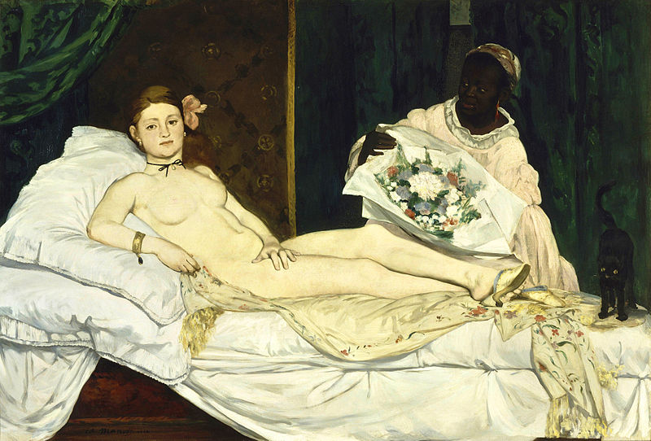
"When our artists give us Venuses, they correct nature, they lie. Édouard Manet asked himself why lie, why not tell the truth; he introduced us to Olympia, this fille of our time, whom you meet on the sidewalks." – Emile Zola

Pierre-Auguste Renoir, The Luncheon of the Boating Party, 1881. Oil on canvas. (Impressionism)
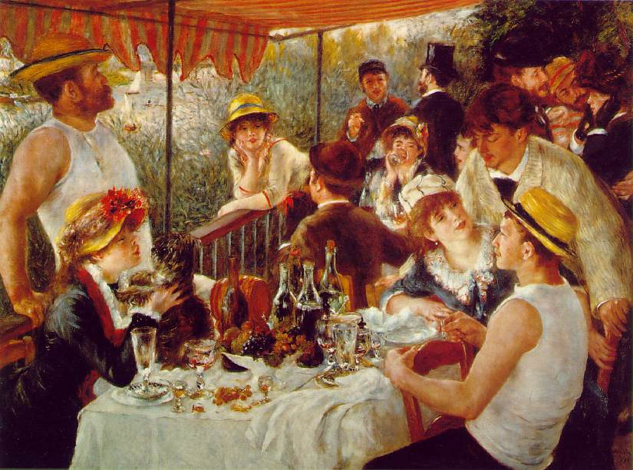
Pierre-Auguste Renoir, Girl with a Watering Can, 1876 (Impressionism)
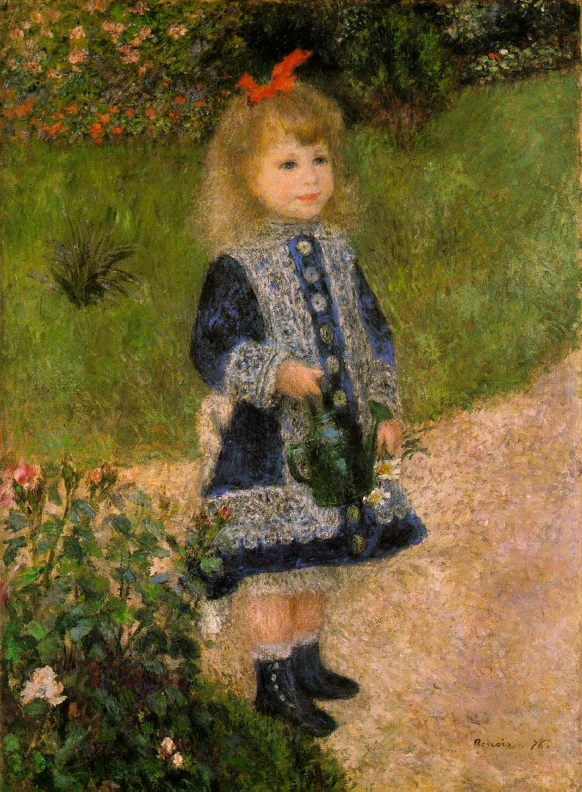

Claude Monet, The Saint-Lazare Station, 1877. (Impressionism)
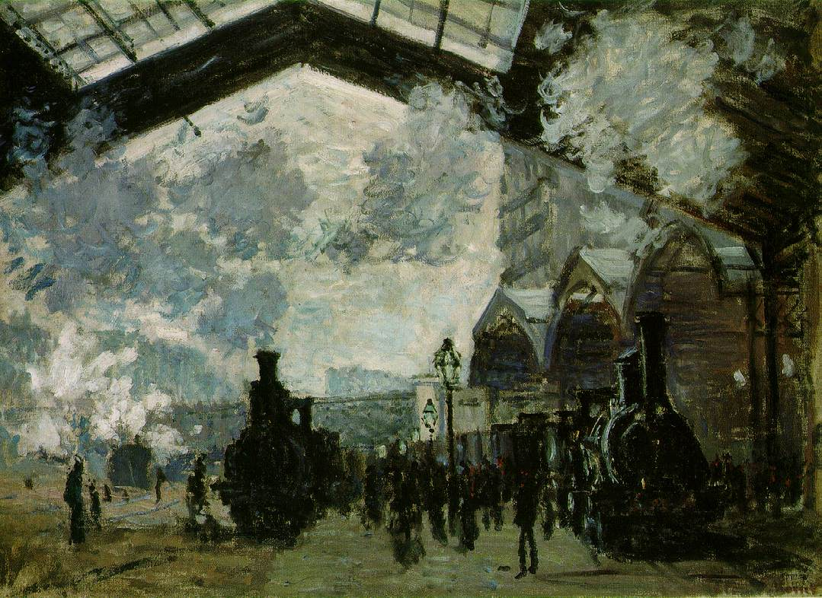

Edgar Degas, The Rehearsal, 1878 (Impressionism)
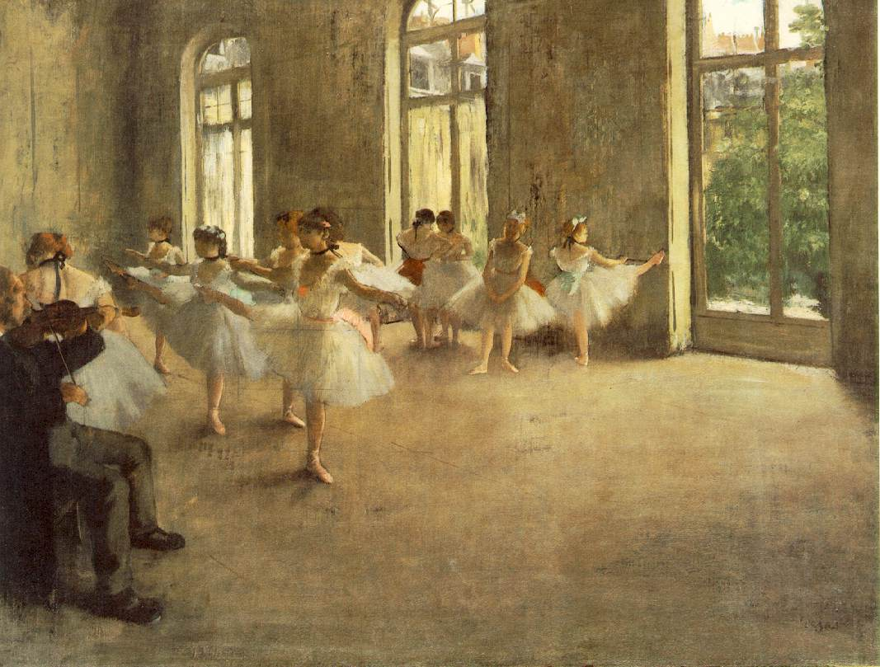
Edgar Degas, Henri Rouart in Front of His Factory, 1875 (Impressionism)
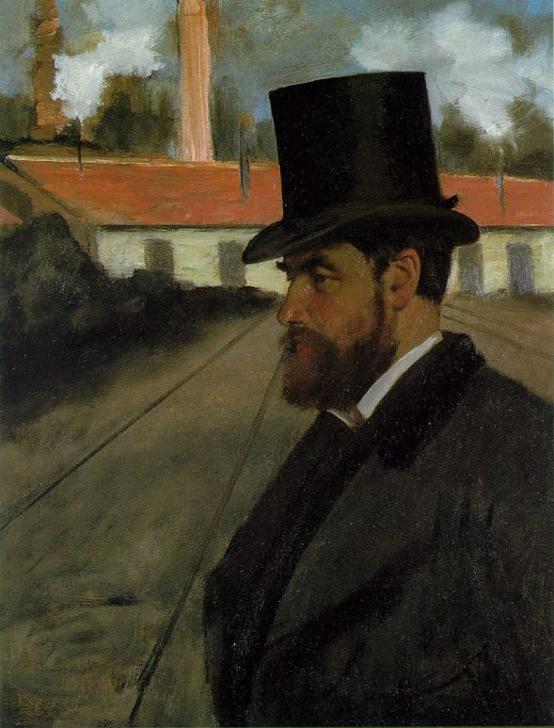
Paul Cezanne, The Card Players, 1895. (Post-Impressionism)
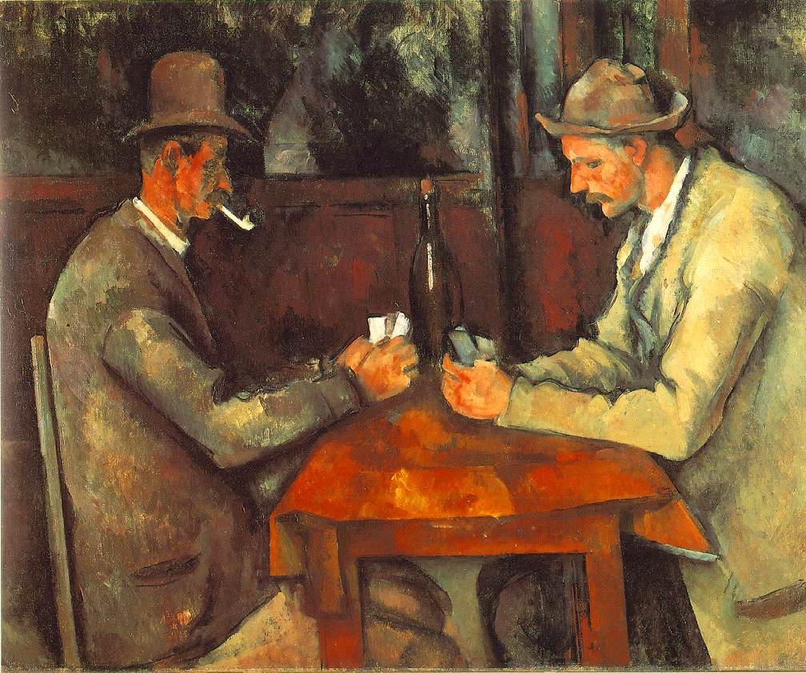

Vincent Van Gogh, The Starry Night, 1889 (Post-Impressionism)
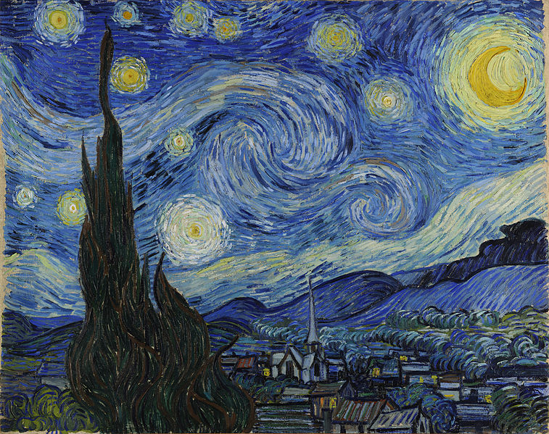

Georges Seurat, View of Le Cretoy, 1889 (Post-Impressionism)
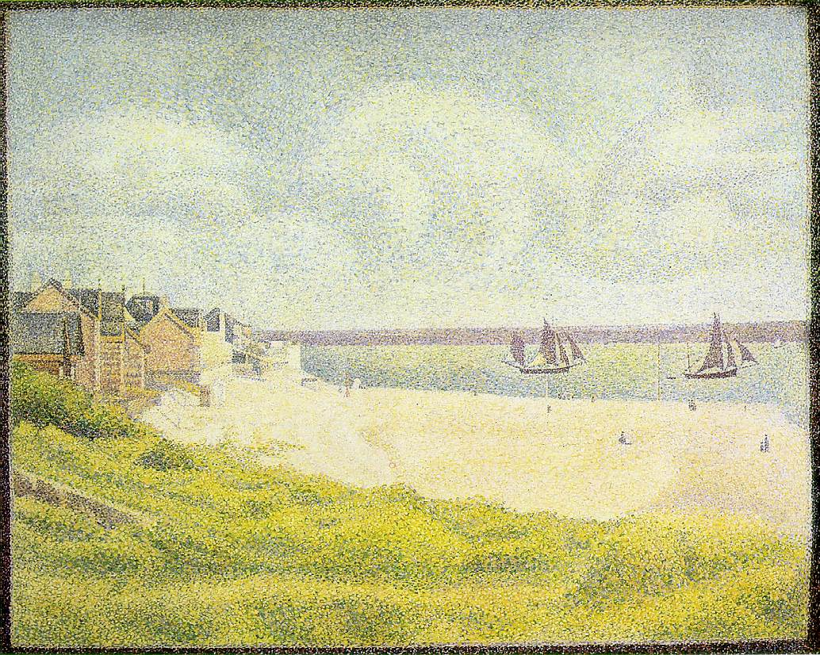
Pablo Picasso, Les Damoiselles d’Avignon, 1907. (Cubism)
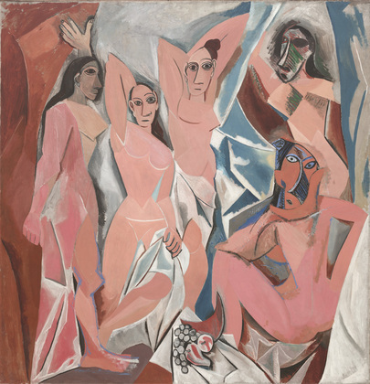
Georges Bracque, Man With a Guitar, 1911. (Cubism)
