SOAP Document
Speaker |  | Who is the speaker?  - Voice
Occasion | 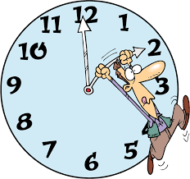 | What is the occasion?  - Time and place
Audience | 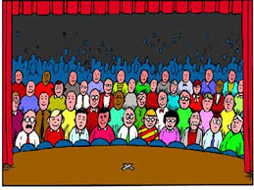 | Who is the audience?  - Group of readers for whom this text was meant for
Purpose |  | What is the purpose?  - What is the reason behind the text?
Subject | 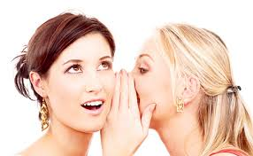 | What is the subject?  - What is the subject of the document?
Tone |  | What is the tone?  - What is the attitude of the author? Serious, sarcastic etc.

